**Computing Research Project**

**New Business Models**

**Name :**

**Syukur Sidiq Nur Alam**

**(STTB)**

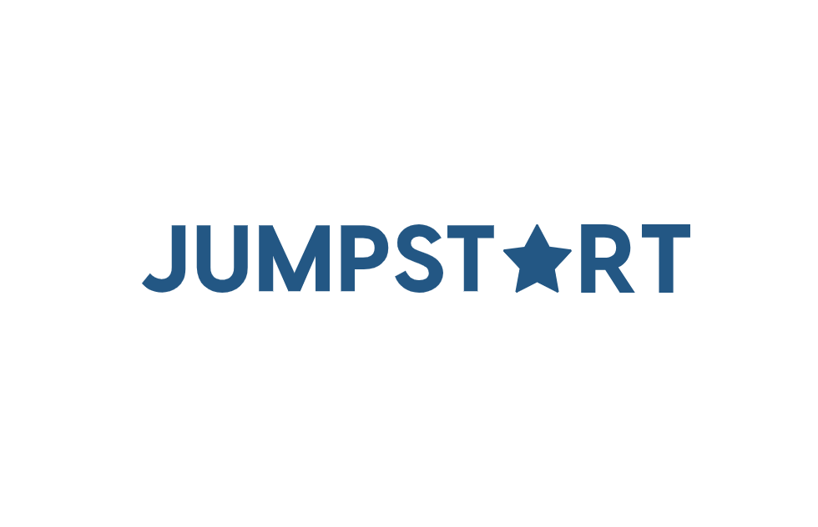

**Lithan EduClaas**

**2023**

* Page 1 - Research Title along with Your Name – Cover Page
* Page 2 - Abstract
* Page 3 - Acknowledgement
* Page 4 - Table of Contents

Table of Contents

**RESEARCH PART (PART I)** 3

1. Introduction 3

1.1 Research Background and Purpose 3

2. Literature Review 4

3. Research Plan 5

3.1 Research: 5

3.2 Research Philosophy 5

3.3 Gantt Chart and Work Breakdown Structures (WBS) 7

4. Research Methodologies 8

4.1 Primary Research 8

4.2 Secondary Research 12

4.3 Secondary Research 14

5. Research Approaches 14

5.1 Qualitative Research 14

5.2 Quantitative Research 17

5.3 Mixed Research Approach 19

6. Research Design 22

6.1 Saunders Research Onion Theory 22

6.2 Compare among research methods and research approaches 22

7. Research Conduct and Analysis 24

7.1 Conduct Primary Research 24

7.2 Conduct Secondary research (Identify Tools and techniques): 29

References 30

8. Project Proposal 31

9. Communication with Stakeholders: 31

10. Project Implementation: attach all evidence of implementation 31

11. Reflection on Research Methods 32

12. Conclusion: summary of how you have successfully achieved your CRP 33

13. Bibliography: in Harvard Referencing system 33

[14. Appendix: rest evidence attaches here both survey templates SS /observation and witness records, *Research Proposal Template* 33

**ABSTRACT**

In order to meet the problems given by the post-COVID-19 economic environment, the system focuses on a new business model at Jumpstart, a retail chain with 750 locations across the nation. And by digitizing the system, this system seeks to enhance the reputation of Jumpstart. Technologies like WordPress, Pantheon, and MySQL Workbench are used in this study. programming languages like PHP, JavaScript, CSS, and HTML. Additionally, add-ons for plugins like Elementor, WooCommerce, and WooCommerce Essentials. Digital ordering and payments are the site's main features, which are designed to minimize interactions, adhere to protocol requirements, and enhance JumpStart's reputation.

# **RESEARCH PART (PART I)**

## Introduction

The purpose of this essay was to improve Jumpstart's retail company, which has 750 locations and has seen operations decline since Covid-19's entry. In order to continue improving Jumpstart's business operations, I plan to develop a new business model with the goal of digitalizing all aspects of the company's shopping experience, from browsing products to placing orders to processing payments.

### Research Background and Purpose

The discussion at hand revolves around the critical examination of business model transformation in response to the distinct challenges posed by the post-Covid landscape, with a specific emphasis on harnessing the potential of digital technologies. Before delving into the research objectives, it is imperative to understand the context that preceded the Covid-19 pandemic. In the pre-Covid era, traditional business models had their established norms and operations. However, with the sudden outbreak of the pandemic, the global business landscape witnessed unprecedented disruption. This disruption unfolded in multiple phases, including the initial shockwaves during the outbreak, the adaptive measures taken by businesses to survive during Covid-19, and the subsequent transformation strategies implemented as we entered the post-Covid era. These phases are pivotal in shaping the research's focus.

The primary objective of this research is to comprehensively explore the adaptability of businesses in the face of evolving circumstances, especially during and after the Covid-19 pandemic. The Covid-19 pandemic served as a catalyst for change, compelling businesses to rethink and reconfigure their operations. Digital technology adoption emerged as a critical factor in reshaping business models, but its significance requires empirical validation. Therefore, this research endeavors to formulate and test hypotheses to assess the impact of digital technology adoption on the transformation of business models. Additionally, it seeks to analyze successful case studies that exemplify the tangible outcomes of these transformations on organizational performance.

Moreover, the research aims to offer strategic insights to guide businesses in adapting and thriving within the rapidly evolving digital ecosystem that has emerged post-Covid. It also addresses the tangible issues pertaining to this discussion. These issues encompass the pivotal role of digital technologies in enhancing business agility, fostering customer engagement, and driving operational efficiency within the newly transformed business models that have emerged in the post-Covid era. In essence, this research seeks to provide a holistic understanding of the challenges, adaptations, and opportunities that businesses encountered and leveraged in the wake of the Covid-19 pandemic, with a specific focus on digital transformation.

### Research Objectives

This study's main objective is to evaluate the impact of cutting-edge tech-based business models on consumer interactions and purchasing decisions in the post-pandemic age, with an emphasis on retailers like Jumpstart. This goal is based on Jumpstart's strategic vision, which emphasizes the seamless integration of personalized suggestions and app-based ordering. The ultimate goal is to enhance the shopping experience in order to generate greater client involvement and boost revenues.

## Literature Review

The excellent growth of the restaurant industry has been hampered by the pandemic

Covid-19 pandemic. This forces entrepreneurs to adapt in order to survive.

This research aims to provide a business model proposal during the Covid-19 pandemic for PT XYZ.

Covid-19 pandemic for PT XYZ using the Business Model. From the research results, there are several focuses that

can be applied by PT XYZ to its business model during the Covid-19 pandemic.

pandemic. These focuses are improving service quality by educating

employees, increased promotion on the internet, increased delivery services and

implementation of strict health protocols in accordance with government regulations.

Muslimin. H (2021)

## Research Plan

### Research:

**What is research**

according to Deb et al., (2019), engineering research is the process of developing the perspectives and seeking improvements in knowledge and skills to enable the recognition, planning, design, and execution of research in a wide range of forms relevant for engineering and technology investigations and developments.

Commencing with a description of a prevalent global issue that poses concerns and demands attention, there exists a need to address certain challenges. These challenges may stem from an ambition to attain specific goals, hindered by a lack of requisite knowledge. Additionally, there could be instances where an efficient process or system operates successfully, but its underlying principles remain enigmatic, warranting a comprehensive understanding. Alternatively, one might embark on an exploratory endeavor with the objective of observing anticipated consequences.

by citing from Wohlin & Runeson, (2021) The research plan should have a clearly defined scope to ensure successful completion of the project. It must be guided by the research question and specific aims or objectives. In practice-based research, valuable research questions can often be found in clinical settings. It is essential that the research idea is realistic and relevant both to the investigators' interests and the organization and its patients. After the lead investigator has formulated the research idea, a comprehensive literature review should be conducted.

The project's aims should be new, concise, relevant, and achievable. Adequate time should be allocated to thoughtfully develop and refine the research question and objectives using principles of project management. It is crucial to establish a collaborative team early in the research planning process to ensure successful project completion. Delegating tasks among team members can help distribute the workload effectively.

### Research Philosophy

**Saunders's Onion Theory**

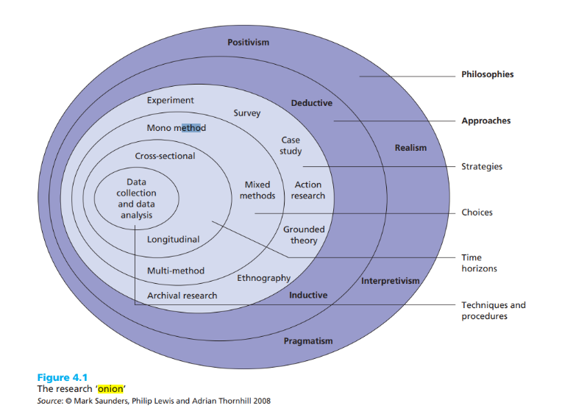(Saunders et al., n.d.) Saunders's Onion Theory is a model that helps researchers to design and conduct their research projects. It is called an onion theory because it consists of different layers that represent different aspects of the research process. The idea is that researchers need to peel back each layer of the onion, starting from the outermost one, and make decisions about each aspect before moving on to the next layer. By doing so, they can develop a coherent and logical research methodology that suits their research questions and objectives. The six layers of Saunders's Onion Theory are: research philosophy, research approach, research strategy, choices, time horizon, and techniques and procedures.

Figure 1 Saunder's Onion Theory

**The stage of Saunders's Onion Theory**

According to the research of (Saunders et al., n.d.)

Philosophies: This outer layer represents the broad philosophical positions that underpin research, such as positivism, interpretivism, realism, and pragmatism. Researchers need to consider their philosophical stance, as it shapes their worldview and approach to research.

Approaches: Moving inward, this layer encompasses different research approaches or traditions associated with each philosophy. For example, under positivism, you might find experimental and survey research approaches, while under interpretivism, you could have ethnography and case study approaches.

Strategies: The next layer involves research strategies that align with specific approaches. For instance, within the case study approach, you might choose an exploratory, descriptive, or explanatory strategy.

Time Horizons: This layer pertains to the time dimension of research, distinguishing between cross-sectional (snapshot) and longitudinal (over time) studies.

Techniques and Procedures: At the core of the onion are the specific techniques and procedures used for data collection and analysis. These can include surveys, interviews, content analysis, statistical tests, etc.

### Gantt Chart and Work Breakdown Structures (WBS)

A Gantt chart is a visual representation of a project schedule that displays tasks, activities, or events over time. It was developed by Henry L. Gantt in the 1910s and has since become a widely used project management tool for planning, scheduling, and tracking projects. Gantt charts are particularly useful for visualizing the sequence and duration of tasks within a project.

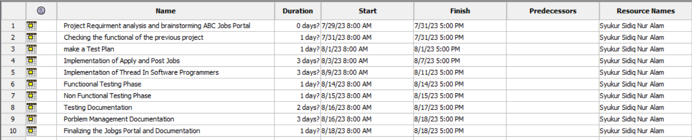



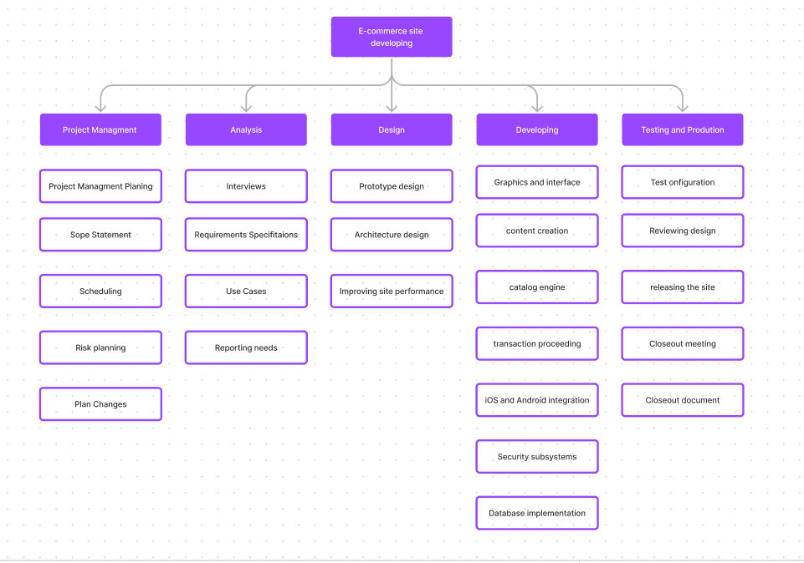

**Work Breakdown Structure** (WBS) is a hierarchical decomposition of a project into smaller, manageable work elements. It is a visual representation of the project's scope, outlining the tasks and deliverables required to complete the project. The primary purpose of creating a WBS is to simplify project planning and management by breaking down complex projects into more manageable components.

## Research Methodologies

* 1. Primary Research

#### Primary Research Methodologies

in accordance with Marczyk et al., (2005) Primary research is a research method that relies on direct data collection, rather than relying on data that’s already been collected by someone else. In other words, primary research is any type of research that you undertake yourself, firsthand, while using data that has already been collected is called secondary research.

Example: Primary research

You are interested in the quality of vegan options offered at your campus dining hall. You decide to conduct a survey of vegan students, asking them their thoughts.

#### Survey

Referring to Moser C.A & Kalton G, (2016)

The subject matter of surveys is vast and covers various aspects of human behavior. Four broad types of subject matter are identified in this chapter: demographic characteristics, social environment, activities, and opinions and attitudes. Demographic characteristics include family composition, marital status, age, fertility, and more. Social environment encompasses social and economic factors such as occupation, income, housing conditions, and social amenities. Activities refer to what people do, such as leisure activities, travel habits, expenditure patterns, and media consumption. Opinions and attitudes are examined in surveys called opinion polls, though they are only of marginal importance in many other surveys. Surveys on demographic characteristics and social environment are relatively easier to collect and have less room for error than surveys on behavior and opinions. The accuracy of factual data can be verified more frequently. This chapter highlights the diverse range of topics that social surveys explore and differentiates between the different types of subject matter surveyed. The subsequent chapter delves into the challenges associated with collecting information on opinions and attitudes.

#### Interview

An interview is a purposeful discussion between two or more people (Kahn and Cannell 1957).

The use of interviews can help you to gather valid and reliable data that are relevant to your

research question(s) and objectives. Where you have not yet formulated such a research question and objectives, an interview or interviews may help you to achieve this. In reality, the

research interview is a general term for several types of interview. This fact is significant since

the nature of any interview should be consistent with your research question(s) and objectives,

the purpose of your research and the research strategy that you have adopted.

#### Observations

per the Findings of(Saunders et al., n.d.)

Delbridge and Kirkpatrick (1994) categorise the types of data generated by participant observation as ‘primary’, ‘secondary’ and ‘experiential’. Primary observations are those where you would note what happened or what was said at the time. Keeping a diary is a good way of doing this. Secondary observations are statements by observers of what happened or was said. This necessarily involves those observers’ interpretations. Experiential data are those data on your perceptions and feelings as you experience the process you are researching. Keeping a diary of these perceptions proves a valuable source of data when the time comes to write up your research. This may also include notes on how you feel that your values have intervened, or changed, over the research process.

#### Focus Group

Focus groups are well known because of the way they have been used by political parties to test voter reactions to particular policies and election strategies, and through their use in market research to test reactions to products. A focus group, sometimes called a ‘focus group interview’, is a group interview that focuses clearly upon a particular issue, product, service or topic and encompasses the need for interactive discussion amongst participants (Carson et al. 2001). This means that, in comparison with other forms of group interview, individual group members’ interactions and responses are both encouraged and more closely controlled to maintain the focus. Participants are selected because they have certain characteristics in common that relate to the topic being discussed and they are encouraged to discuss and share their points of view without any pressure to reach a consensus (Krueger and Casey 2000). These discussions are conducted several times, with similar participants, to enable trends and patterns to be identified when the data collected are analysed.

(Saunders et al., n.d.)

#### Merits/Demerits/Pitfalls

1. Survey Method:

- Advantages: Suitable for data collection from large samples, quantifiable results, and efficient.

- Weaknesses: Potential for respondent bias, limitations in understanding context, and high costs in complex surveys.

- Potential Errors: Sampling error, non-response, or tendency for inaccurate answers.

2. Interview Method:

- Advantages: In-depth qualitative data, clarification of questions, and better rapport between researcher and respondent.

- Weaknesses: Time and effort required, possible interview bias, and difficult for large samples.

- Potential Errors: Interview tendencies, researcher subjectivity, or biased judgment.

3. Observation Method:

- Advantages: Objective data, direct observation, and understanding behavior without intervention.

- Weaknesses: Difficult to observe internal aspects or thoughts, sometimes difficult to implement, and takes time.

- Potential Errors: Limitations in observation, researcher subjectivity, or influence of attention.

4. Document Analysis Method:

- Advantages: Data already exists, can provide historical insights, and is cost-efficient.

- Weaknesses: Not always relevant documents, possible incomplete documents, and difficulties in interpretation.

- Potential Errors: Interpretation errors, incomplete data, or researcher bias in document selection.

5. Experimental Method:

- Advantages: Tight control over variables, can identify cause-and-effect, and high internal validity.

- Weaknesses: Less representative, difficult to apply in real situations, and high cost.

- Potential Errors: Experimental bias, limited generalizability, or contamination of effects.

### Secondary Research

According to [Bhat, (2023)](https://www.questionpro.com/blog/secondary-research/) secondary research is a research method that involves using already existing data. Existing data is summarized and collated to increase the overall effectiveness of the research.

One of the key advantages of secondary research is that it allows us to gain insights and draw conclusions without having to collect new data ourselves. This can save time and resources and also allow us to build upon existing knowledge and expertise.

#### Sources of data

According to [Villegas F, (2023)](https://www.questionpro.com/blog/sources-of-data/)

In short, the sources of data are physical or digital places where information is stored in a data table, data object, or some other storage format.

Data can be gathered from two places: internal and external sources. The information collected from internal sources is called “primary data,” while the information gathered from outside references is called “secondary data.”

#### Secondary Research Methodologies

[Bhat, (2023)](https://www.questionpro.com/blog/secondary-research/)

Secondary research is a research method that involves using already existing data. Existing data is summarized and collated to increase the overall effectiveness of the research.

One of the key advantages of secondary research is that it allows us to gain insights and draw conclusions without having to collect new data ourselves. This can save time and resources and also allow us to build upon existing knowledge and expertise.

#### Merits/Demerits/Pitfalls

1. Document Analysis Method:

- Merits: Existing data, cost-efficient, and can provide historical insights.

- Demerits: Not always relevant documents available, potential for incomplete documents, and difficulty in interpretation.

- Potential Pitfalls: Interpretation errors, data incompleteness, or researcher bias in document selection.

2. Secondary Data Analysis Method:

- Merits: Utilizes existing data, time and cost-efficient, and suitable for long-term research.

- Demerits: Limited to available data, lack of control over original data collection methods, and potential data quality issues.

- Potential Pitfalls: Errors in data interpretation, misunderstanding the source of data, or researcher bias in analysis.

3. Meta-analysis Method:

- Merits: Combines existing research findings, enhances generalization, and identifies strong trends.

- Demerits: Relies on the quality of existing research, challenging if existing data is inconsistent, and requires a deep understanding of statistics.

- Potential Pitfalls: Bias in the selection of included studies, bias in data analysis, or bias in reporting findings.

4. Systematic Review Method:

- Merits: A systematic approach to evaluating literature, can identify research gaps, and provides in-depth insights.

- Demerits: Time-consuming, variation in literature assessment methods, and limited to existing literature.

- Potential Pitfalls: Bias in the selection of included studies, subjectivity in literature assessment, or bias in synthesizing findings.

### Secondary Research

Secondary research, also known asonline research, involves the collection and analysis of existing data, information, and documents rather than gathering new data through primary research methods like surveys or interviews. Document analysis is a specific technique within secondary research where researchers examine and evaluate various types of documents to extract valuable insights.

## Research Approaches

### Qualitative Research

in keeping with (Creswell & David Creswell, n.d.)

In qualitative research, inquirers employ theory as a broad explanation, much like in quantitative research, such as in ethnographies. It may also be a theoretical lens or perspective that raises questions related to gender, class, race, or some combination of these. Theory also appears as an end point of a qualitative study, a generated theory, a pattern, or a generalization that emerges inductively from data collection and analysis. Grounded theorists, for example, generate a theory grounded in the views of participants and place it as the conclusion of their studies. Some qualitative studies do not include an explicit theory and present descriptive research of the central phenomenon

#### Methodologies in Qualitative Research

Example qualitative research

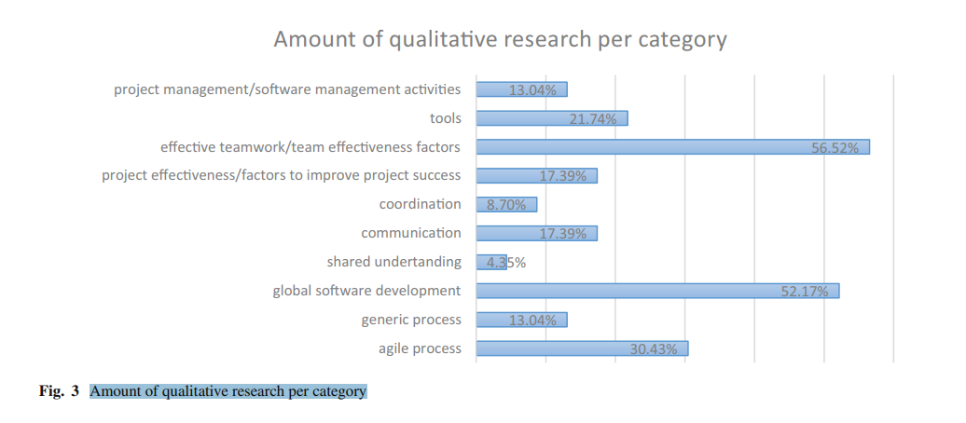

DeFranco & Laplante (2017)

#### Merits/Demerits of Qualitative Research

Merits (Advantages) of Qualitative Research:

Rich Data Collection: Qualitative research allows for in-depth exploration and understanding of complex phenomena. It is particularly useful for studying social and behavioral aspects where context and meaning are essential.

Flexibility: Qualitative research is flexible and adaptable. Researchers can adjust their methods and questions during the research process, allowing them to explore unexpected findings.

Contextual Insight: Qualitative research provides context-rich data that helps researchers understand the "why" and "how" behind behaviors, attitudes, and experiences.

Subjective Understanding: It allows researchers to capture the subjective experiences and perspectives of participants, offering insights into their worldviews.

Emergent Design: Qualitative research often employs an emergent or iterative design, allowing researchers to refine their research questions and methods as they gather data.

Holistic Approach: It takes a holistic approach to research, considering the whole picture rather than isolating variables. This can be especially valuable in social sciences and humanities.

Real-World Applicability: Qualitative research often leads to practical recommendations and insights that can be applied to real-world situations, including policy and practice.

Demerits (Disadvantages) of Qualitative Research:

Limited Generalizability: One of the primary criticisms is that findings from qualitative studies are not easily generalizable to broader populations. Qualitative research often involves small, non-random samples.

Subjectivity: Qualitative research is more susceptible to researcher bias and subjectivity. Interpretation and analysis are influenced by the researchers' perspectives.

Resource-Intensive: Qualitative research can be time-consuming and resource-intensive. Data collection and analysis require careful planning and execution.

Difficulty in Data Analysis: Analyzing qualitative data can be complex, as it involves coding, categorizing, and interpreting narratives, making it more prone to interpretation errors.

Small Sample Size: Qualitative studies often involve small sample sizes, which can limit the statistical power of the findings.

Time-Consuming: Collecting and analyzing qualitative data can be time-consuming, which may not be suitable for researchers on tight schedules.

Ethical Considerations: Qualitative research often involves close engagement with participants, raising ethical concerns about confidentiality and informed consent.

Lack of Reproducibility: Qualitative research is less likely to be replicable in the same way quantitative research can be, making it challenging to verify findings.

### Quantitative Research

In accordance with (Creswell & David Creswell, n.d.) for example, determinism suggests that examining the relationships between and among variables is central to answering questions and hypotheses through surveys and experiments. In one case, a researcher might be interested in evaluating whether playing violent video games is associated with higher rates of playground aggression in kids, which is a correlational hypothesis that could be evaluated in a survey design. In another case, a researcher might be interested in evaluating whether violent video game playing causes aggressive behavior, which is a causal hypothesis that is best evaluated by a true experiment. In each case, these quantitative approaches focus on carefully measuring (or experimentally manipulating) a parsimonious set of variables to answer theory guided research questions and hypotheses.

#### Methodologies in Quantitative Research

In quantitative research, methodologies refer to the systematic approaches and techniques used to collect, analyze, and interpret numerical data. These methodologies are essential for conducting empirical studies that involve measuring and quantifying various phenomena.

(Creswell & David Creswell, n.d.)

#### Merits/Demerits of Quantitative Research

Merits (Advantages) of Quantitative Research:

Objectivity: Quantitative research is often considered more objective because it relies on numerical data, reducing the potential for researcher bias.

Generalizability: Findings from quantitative studies can be more easily generalized to larger populations due to the use of random sampling and statistical techniques.

Replicability: Quantitative research is highly replicable, allowing other researchers to conduct similar studies to validate or refute findings.

Precision and Measurement: It offers precise measurement and quantification of variables, making it suitable for testing hypotheses and relationships.

Statistical Analysis: Quantitative data allows for advanced statistical analysis, including regression analysis, ANOVA, and chi-square tests, enabling the examination of complex relationships.

Large Sample Sizes: Quantitative research often involves larger sample sizes, which can enhance the statistical power and reliability of the results.

Efficiency: Data collection in quantitative research can be more efficient, particularly when using structured surveys or experiments.

Comparison: It enables comparisons across groups, variables, or time periods, facilitating the identification of patterns and trends.

Demerits (Disadvantages) of Quantitative Research:

Lack of Depth: Quantitative research may lack the depth of understanding offered by qualitative research, as it focuses on numerical data and may not capture contextual nuances.

Limited Exploration: It may not be suitable for exploring complex or sensitive topics that require in-depth exploration and open-ended responses.

Reduced Flexibility: Quantitative research typically follows a predetermined research design, limiting the ability to adapt to unexpected findings.

Potential for Superficiality: Due to the reliance on closed-ended questions, quantitative studies may produce superficial insights compared to qualitative research.

Risk of Measurement Errors: Measurement instruments used in quantitative research may introduce errors or bias if not carefully designed and validated.

Difficulty in Capturing Change: Quantitative research may struggle to capture subtle or unexpected changes, especially in longitudinal studies.

Resource Intensity: Large-scale quantitative studies can be resource-intensive in terms of time, funding, and personnel.

Limited Understanding of Causality: While quantitative research can identify correlations, it may not provide a deep understanding of causality or underlying mechanisms.

Ethical Considerations: Some ethical concerns, such as informed consent and privacy, can still arise in quantitative research, especially in studies involving sensitive data.

### Mixed Research Approach

A mixed research approach, also known as mixed methods research, is a research design that combines both qualitative and quantitative research methods in a single study. This approach allows researchers to gain a more comprehensive understanding of a research problem by collecting and analyzing both numerical and non-numerical data.

(Creswell & David Creswell, n.d.)

#### Methodologies in Quantitative Research

Quantitative research is a systematic empirical investigation in which data are collected, analyze, and interpreted in numerical form. It is primarily used to quantify variables, establish patterns, and test hypotheses. The methodologies in quantitative research encompass various techniques and approaches to gather and analyze numerical data.

(Creswell & David Creswell, n.d.)

#### Merits/Demerits of Mixed Research

Certainly, here are the merits (advantages) and demerits (disadvantages) of a mixed research approach:

**Merits (Advantages) of Mixed Research Approach:**

1. Comprehensive Understanding: A mixed research approach combines the strengths of both quantitative and qualitative methods, providing a more comprehensive understanding of research questions or problems.

2. Triangulation: Researchers can use triangulation, which involves comparing and contrasting findings from quantitative and qualitative data sources, to enhance the validity and reliability of results.

3. Diverse Data: It allows for the collection of diverse data types, including numerical data (quantitative) and rich textual or visual data (qualitative), which can capture a broader range of information.

4. Contextual Insights: Qualitative data in mixed research can provide valuable contextual insights that help explain quantitative results, making the findings more meaningful.

5. In-Depth Exploration: Qualitative research can be used to explore unexpected findings from quantitative research, allowing researchers to delve deeper into specific areas of interest.

6. Enhanced Validity: The combination of methods can improve the overall validity of the research, as it addresses potential biases and limitations of each method.

7. Flexibility: Researchers have the flexibility to adapt their research design based on emerging insights, increasing the adaptability of the study.

8. Richer Interpretation: Qualitative data can enrich the interpretation of quantitative results by providing real-world examples, stories, and participant perspectives.

9. Mixed Methods Designs: Researchers can choose from various mixed methods designs, such as convergent, explanatory sequential, or exploratory sequential, to suit their research objectives.

**Demerits (Disadvantages) of Mixed Research Approach:**

1. Complexity: Conducting mixed research can be more complex than using either method in isolation, requiring expertise in both quantitative and qualitative techniques.

2. Resource-Intensive: Mixed research may demand more time, funding, and resources compared to single-method approaches, as it involves data collection and analysis from multiple sources.

3. Integration Challenges: Combining quantitative and qualitative data can be challenging, particularly when merging and interpreting results from different methods.

4. Expertise Required: Researchers must possess skills in both quantitative and qualitative research, or collaboration with experts in each field is necessary.

5. Increased Workload: Mixed research often involves a heavier workload due to the need to manage and analyze data from two distinct methods.

6. Potential for Discrepancies: Quantitative and qualitative findings may sometimes conflict or yield different results, requiring careful consideration and explanation.

7. Time-Consuming: The integration of findings from different methods can be time-consuming, delaying the research process.

8. Data Management: Researchers must manage and store diverse data types, which can be logistically challenging.

9. Complex Reporting: Communicating findings effectively in research reports or publications may be more complex, as it requires presenting results from both methods in a coherent manner.

## Research Design

### Saunders Research Onion Theory

a conceptual framework used in research methodology to guide researchers in the process of selecting research methods and approaches. The onion metaphor represents the layers of complexity in research, with each layer representing a different aspect of the research process. Here's an explanation of the key layers or stages of the Saunders Research

(Creswell & David Creswell, n.d.)

### Compare among research methods and research approaches

**Comparison of data Approaches**

|  |  |  |
| --- | --- | --- |
| Quantitative Research | Qualitative Research | Mixed Research |
| • Experimental designs  •Nonexperimental designs, such as surveys  •Longitudinal designs | •Narrative research  •Phenomenology  •Grounded theory  •Ethnographies  •Case study | • Convergent  •Complex designs with embedded core designs  •Exploratory sequential  •Explanatory sequential |

Conclusion:

The choice of research approach should align with the research questions, objectives, and the nature of the study. In this context, selecting the best approach involves considering the following

- The specific research questions

- The depth of understanding required

- The available resources and timeline

- The research context

- The need for triangulation

**Comparison among primary methods:**

|  |  |  |  |
| --- | --- | --- | --- |
| **Survey** | Interview | Focus group | Observation |
| A survey is a method of collecting data from a large number of respondents using a standardized questionnaire. Surveys can be conducted online, by phone, by mail, or in person. Surveys are useful for measuring attitudes, opinions, preferences, behaviors, and other variables of interest. Surveys can provide quantitative data that can be analyzed statistically. However, surveys may also have some limitations, such as low response rates, sampling errors, social desirability bias, and lack of depth and context | An interview is a method of collecting data from one or a few respondents using a semi-structured or unstructured conversation. Interviews can be conducted face-to-face, by phone, by video call, or by email. Interviews are useful for exploring complex and sensitive topics, gaining insights into personal experiences and perspectives, and generating rich and detailed data. Interviews can provide qualitative data that can be analyzed thematically. However, interviews may also have some challenges, such as time and resource constraints, interviewer bias, reliability and validity issues, and ethical considerations | A focus group is a method of collecting data from a small group of respondents using a moderated discussion. Focus groups can be conducted in person or online. Focus groups are useful for generating diverse and dynamic views and opinions, stimulating new ideas and insights, and observing group interactions and dynamics. Focus groups can provide qualitative data that can be analyzed thematically. However, focus groups may also have some drawbacks, such as difficulty in recruitment and scheduling, groupthink and conformity, dominance and inhibition, and moderation and analysis challenges | Observation is a method of collecting data by watching and recording a specific activity or phenomenon. Observation can be conducted in natural or controlled settings, and can be overt or covert, participant or non-participant, structured or unstructured. Observation is useful for studying behaviors, processes, contexts, and interactions that may not be easily captured by other methods. Observation can provide qualitative or quantitative data that can be analyzed descriptively or inferentially. However, observation may also have some limitations, such as observer bias, reactivity, ethical issues, and generalizability |

Conclusion: In conclusion, survey, interview, focus group, and observation are four primary research methods that have different advantages and disadvantages depending on the research objectives, questions, and context. Researchers should carefully consider the suitability, feasibility, and ethical implications of each method before choosing one or more for their data collection.

**Comparison of secondary methods**

|  |  |  |  |
| --- | --- | --- | --- |
| **LR/document analysis** | Grounded Theory | **Case Study** | Ethnography |
| a method of reviewing and synthesizing existing literature or documents related to a research topic or question. It can be used to identify gaps, trends, themes, or patterns in the literature or to provide background information or context for a study. LR/document analysis can be done as a standalone method or as part of a larger research design, such as a case study or a grounded theory. | an approach that uses simultaneous data collection and analysis to generate a theory that is grounded in the data. It involves a systematic and iterative process of coding, categorizing, and conceptualizing the data, as well as constant comparison and theoretical sampling. Grounded Theory can be applied in various types of research, such as ethnography, case study, historical or action research, and can accept qualitative, quantitative, or hybrid data. | a method of in-depth and detailed investigation of a specific case or phenomenon within its real-world context. It can use multiple sources of evidence, such as observations, interviews, documents, or artifacts, and can employ various analytical techniques, such as descriptive, explanatory, or evaluative. Case Study can be used to explore, describe, explain, or evaluate a case or phenomenon, and can contribute to theory development or testing. | a method of studying and describing the culture and behavior of a group of people from their perspective. It involves prolonged and immersive fieldwork, where the researcher observes, interacts, and participates in the daily life of the group. Ethnography can use various data collection methods, such as interviews, field notes, or artifacts, and can employ various analytical approaches, such as narrative, thematic, or interpretive. Ethnography can be used to understand, interpret, or represent the culture and meaning of a group of people. |

Conclusion: In this text, I have compared four secondary methods of research: LR/document analysis, Grounded Theory, Case Study, and Ethnography. I have summarized their definitions, applications, data sources, and analytical strategies, and highlighted their differences and similarities. I have also provided web sources for further reference. These methods can be useful for researchers who want to conduct secondary research or use existing data to answer their research questions. However, they also have their own advantages and disadvantages, and require careful consideration of the research design, context, and ethics. Therefore, researchers should choose the most appropriate method or combination of methods for their specific research goals and needs.

## Research Conduct and Analysis

### Conduct Primary Research

**Survey:** complete process of conducting survey:

1. consider costs, access and ethical issues

|  |  |
| --- | --- |
| **Survey_Considerations** | **Description** |
| *Cost* | Google Form is open-source tool to create the survey form. The participants only need to use the internet to participate in surveys. |
| Access | Can access in anywhere internet access. |
| Ethical | Make sure that the participants agree the consent to do the surveys. All the data are kept as confidential. |

1. **Objective of survey**: to understand their Pain points of Jumpstart during covid-19 + to know the actual or complete requirement for the solution they expect.
2. **Identify the tool: for** survey – Google Form
3. **Frame question** for survey:



**Q1.** Do you know the jumpstart sport store website?

A. Not yet

B. I know

C. I've bought on that website

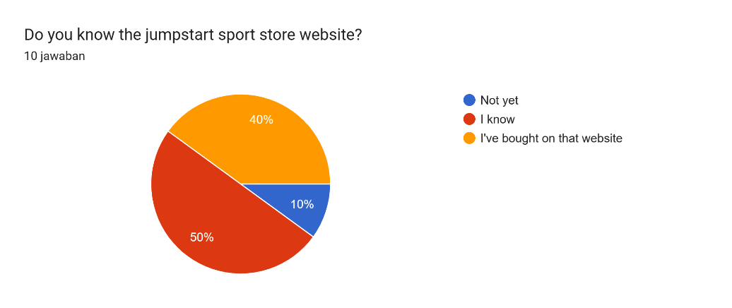

**Q2.** did you ever buy sports equipment on the jumpstart sport store website before covid 19?

A. Yes

B. NO

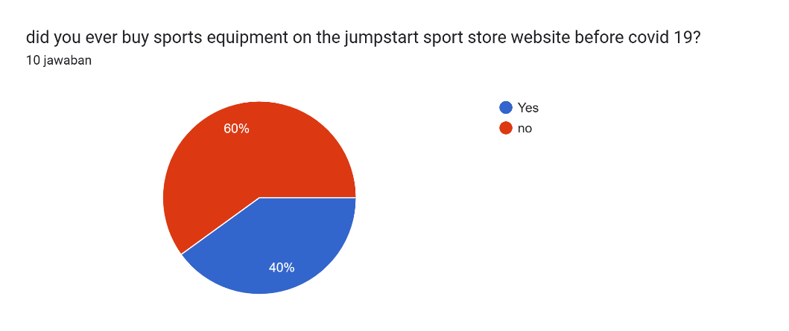

**Q3.** If yes, what was your impression when visiting the jumpstart sport store website before Covid 19?

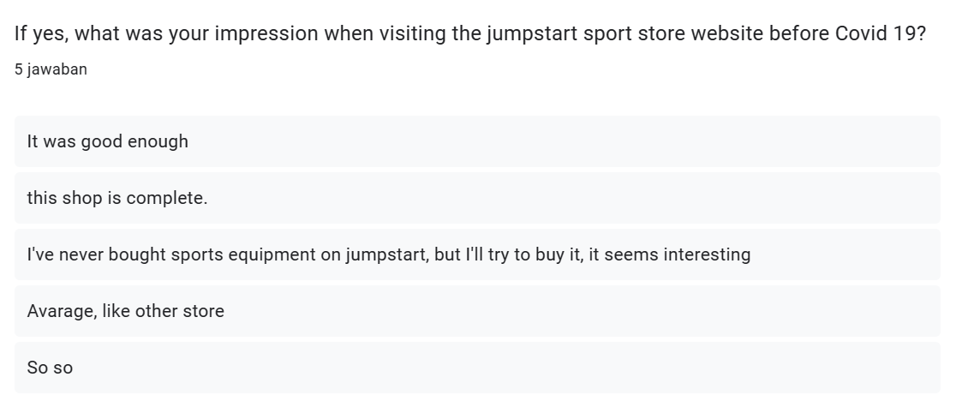

**Q4.** have you ever bought sports equipment on the jumpstart sport store website during covid 19?

A. Yes

B. NO

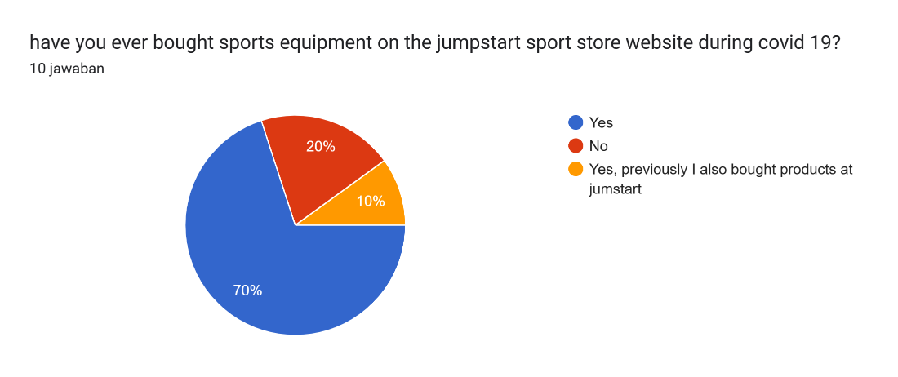

**Q5.** did you feel a change in innovation in the shopping experience on the jumpstart sport store website during covid 19?

A. yes I feel the change in appearance in jumpstart

B. Avarage

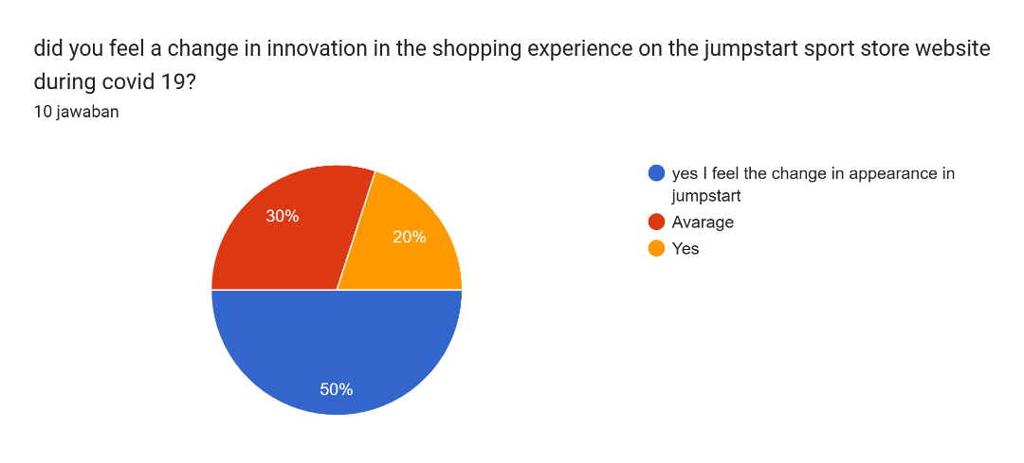

**Q6.** If yes, what are the changes you have experienced while shopping on our website?

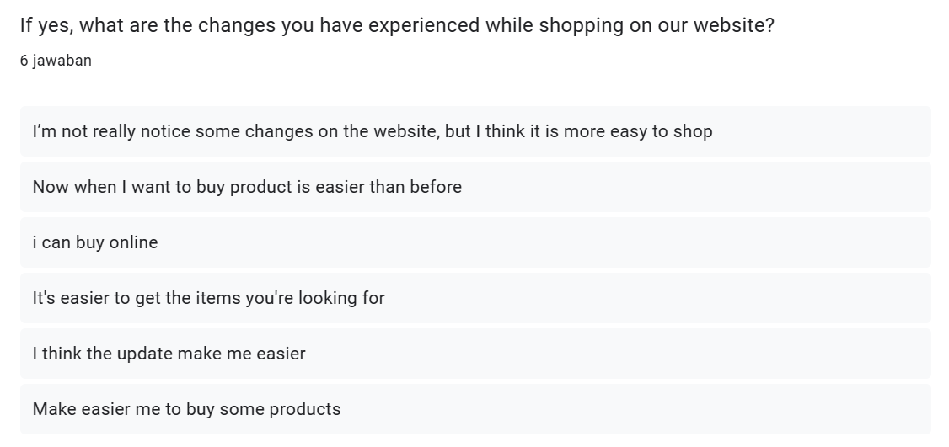

**Q7.** do you find it difficult to buy goods on the jumpstart website?

A. I don't understand the interface

B. Not too difficult

C. the display is very easy to understand.

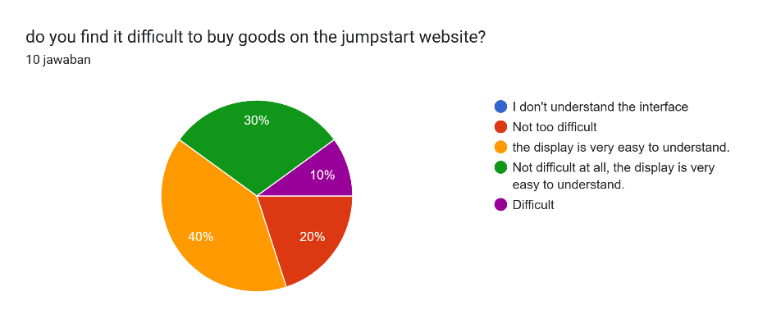

**Q8.** do you feel helped by the Jumpstart sport store website?

A. I don't need to leave the house to buy products

B. Neutral

C. Less helpful

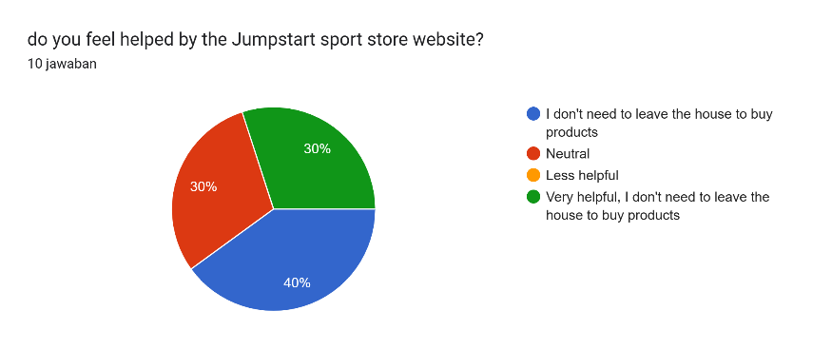

**Q9.**  have you ever bought sports equipment on the jumpstart sport store website after the covid 19 period?

A. Yes

B. I still buy on the jumpstart website

C. No

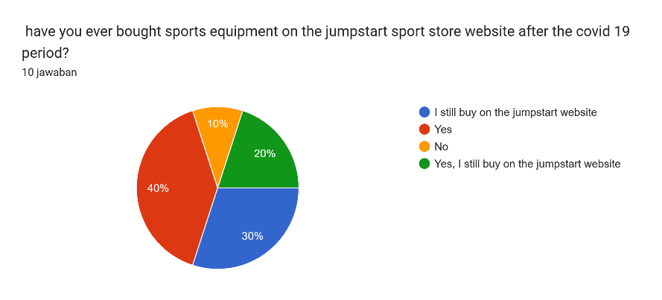

**Q10.**   what do you think about the innovation of the jumpstart sport store website after the covid-19 period?

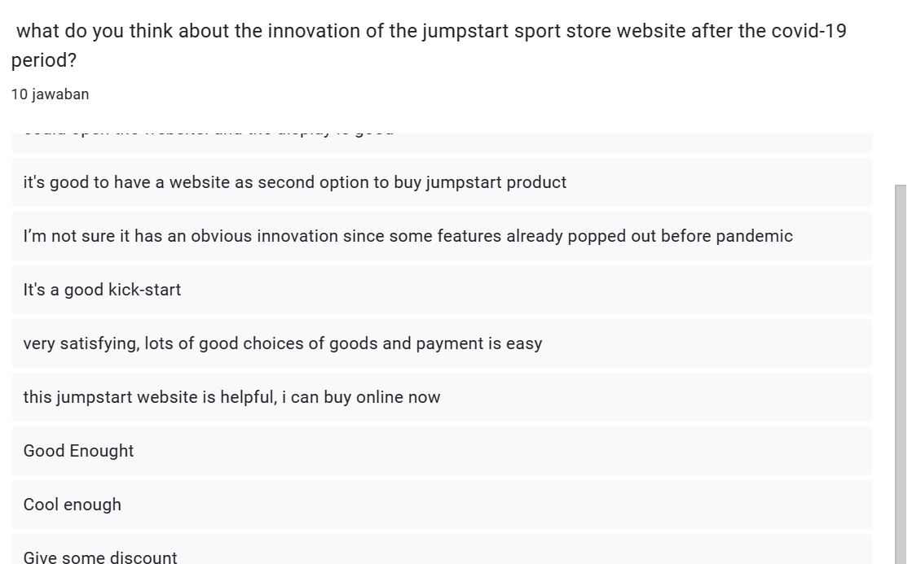

Conclusion: JumpStart faced considerable operational difficulties as a result of the COVID-19 epidemic, especially in its retail activities. Lockdowns and travel restrictions interrupted traditional supply networks, making it difficult to get materials and deliver products on schedule. Additionally, since employees struggled with coordination while working remotely, the shift to remote work highlighted the need for effective digital collaboration tools.

These operational difficulties highlight JumpStart's urgent need for digital transformation (DX). The company can deal with supply chain interruptions, streamline remote work procedures, and adjust to changing consumer patterns, particularly the move toward online purchasing, by embracing DX. DX becomes crucial for guaranteeing operational effectiveness and resilience in JumpStart's shopping operations in a post-pandemic business environment.

### Conduct Secondary research (Identify Tools and techniques):

Consider costs, access and ethical issues.

|  |  |
| --- | --- |
| **Case study_Considerations** | **Description** |
| Cost | I got this information from free sources such as penpoin.com, elicit org, google.schollar.com, sci-hub.s. By using all of this, I don't need to incur any costs |
| Access | Can access in internet, anywhere |
| Ethical | books, the date for publication is around 2000  And for journals, the rules are that they cannot be published before 2013 |

Reference Link:

Secondary Research Analysis (Document based):

Literature Review Process: stepwise highlight

<https://www.questionpro.com/blog/secondary-research/>

https://penpoin.com/primary-research/

https://research.com/research/primary-research-vs-secondary-research

# References

**There are no sources in the current document.**

**Project Part (Part II)**

## Project Proposal

### Project Aim

This project is devoted to reviving a company called jumpstart because of covid 19 so jumpstart lost its buyers, to deal with it we try to create a website so that everyone can buy products without having to come to the store.

Objective, Scope (features which your application can provide to Jumpstart users/employee), Constraints, Assumptions & dependencies

**Project Objective**

regain buyers who used to come to the store to buy on the website, increase the range of buyers from initially around retail, make it easier for buyers not to come to the store.

**Feature**

### Project Environment

**- Hardware requirements**

|  |  |  |  |
| --- | --- | --- | --- |
| **No** | **Hardware** | | |
| **Type** | **Server** | **Client** |
| 1 | Processor | Intel(R) Core(TM) i7-8550U CPU @ 1.80GHz 1.99 GHz | Intel Pentium G4400s |
| 2 | Memory | 32 GB | 4 GB |
| 3 | Hard Drive | 4 TB | 160GB |
| 4 | SSD | 1TB NVMe Gen. 4 | Sata |
| 5 | Network | Gigabit Network | Gigabit Network |
| 6 | Monitor | Asus TUF VG328H1B 31.5" | Monitor 24” |
| 7 | PSU | Seasonic Prime Titanium TX-1000 - 1000W 80+ Titanium Certified | Standard PSU |
| 8 | Keyboard & Mouse | USB Mouse Keyboard | USB Mouse Keyboard |

**- Software requirements**

|  |  |  |
| --- | --- | --- |
| **No** | **Software** | **Functionality** |
| 1 | Windows 10 / Windows 11 | Operating System |
| 2 | CMS WordPress | Web Creation |
| 3 | Google Chrome, Microsoft Edge | Web Browser |

* **Flowchart**

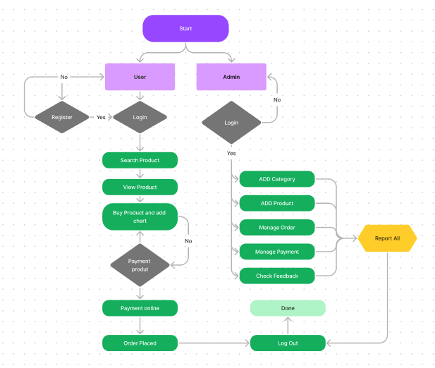

## Communication with Stakeholders:

* List down who are they in this business case

**Communication Matrix: Plan** out the following:

Who are sender and Receiver?

What is the purpose of communication?

What outcome is going to be achieved?

What is the channel of communication? - Medium

What is the frequency of communication?

|  |  |  |  |  |
| --- | --- | --- | --- | --- |
| Sender | Receiver | Purpose | Medium | Frequency |
| Acedora PM | Jumpstart Emplyee/customer | Communicate to provide the solution & recommendation | Microsoft Teams | once in project Life |
| Acedora PM | Senior Manager of Acedora | Plan project flow | Email, Microsoft Teams | Twice per week |
|  |  |  |  |  |

## Project Implementation: attach all evidence of implementation

Landing page

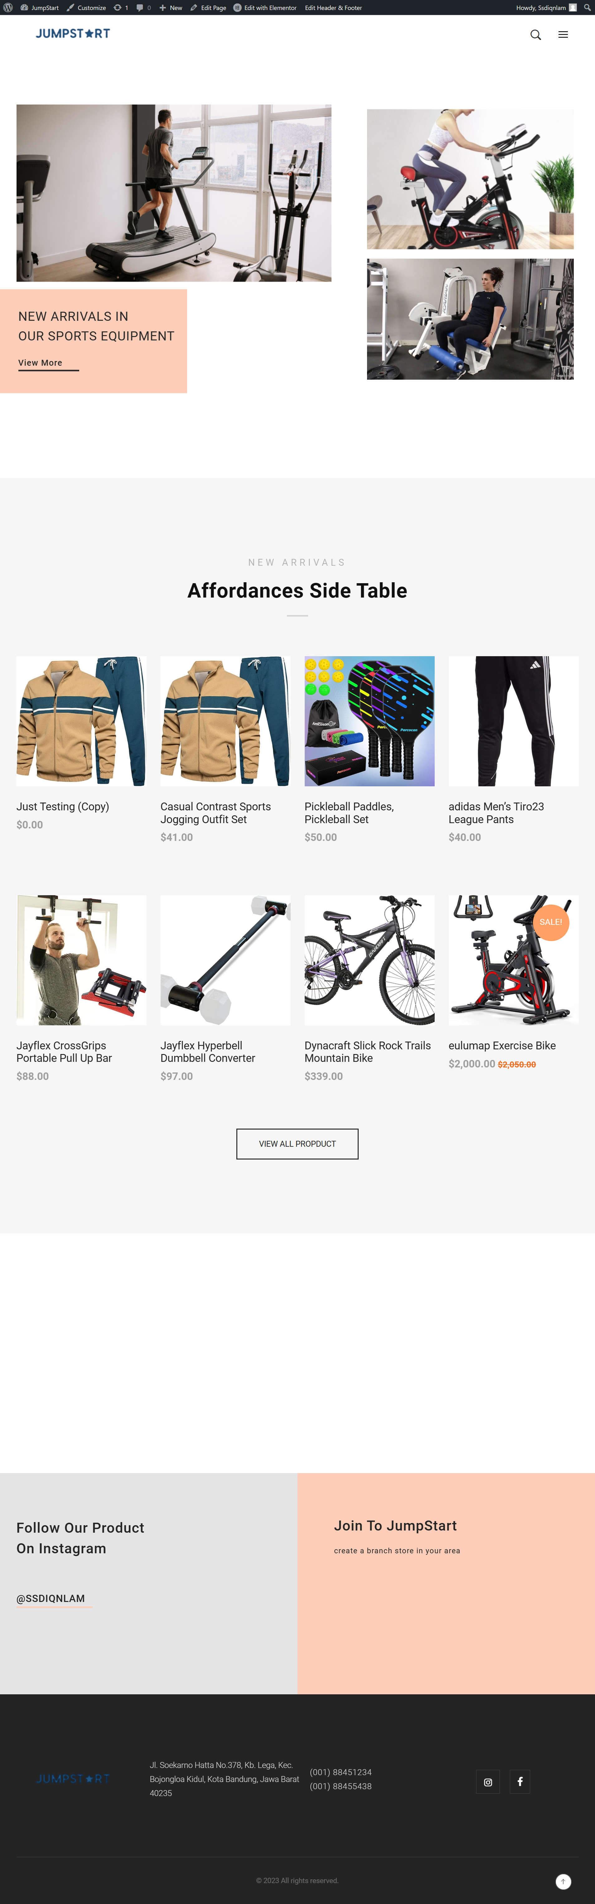

Cart

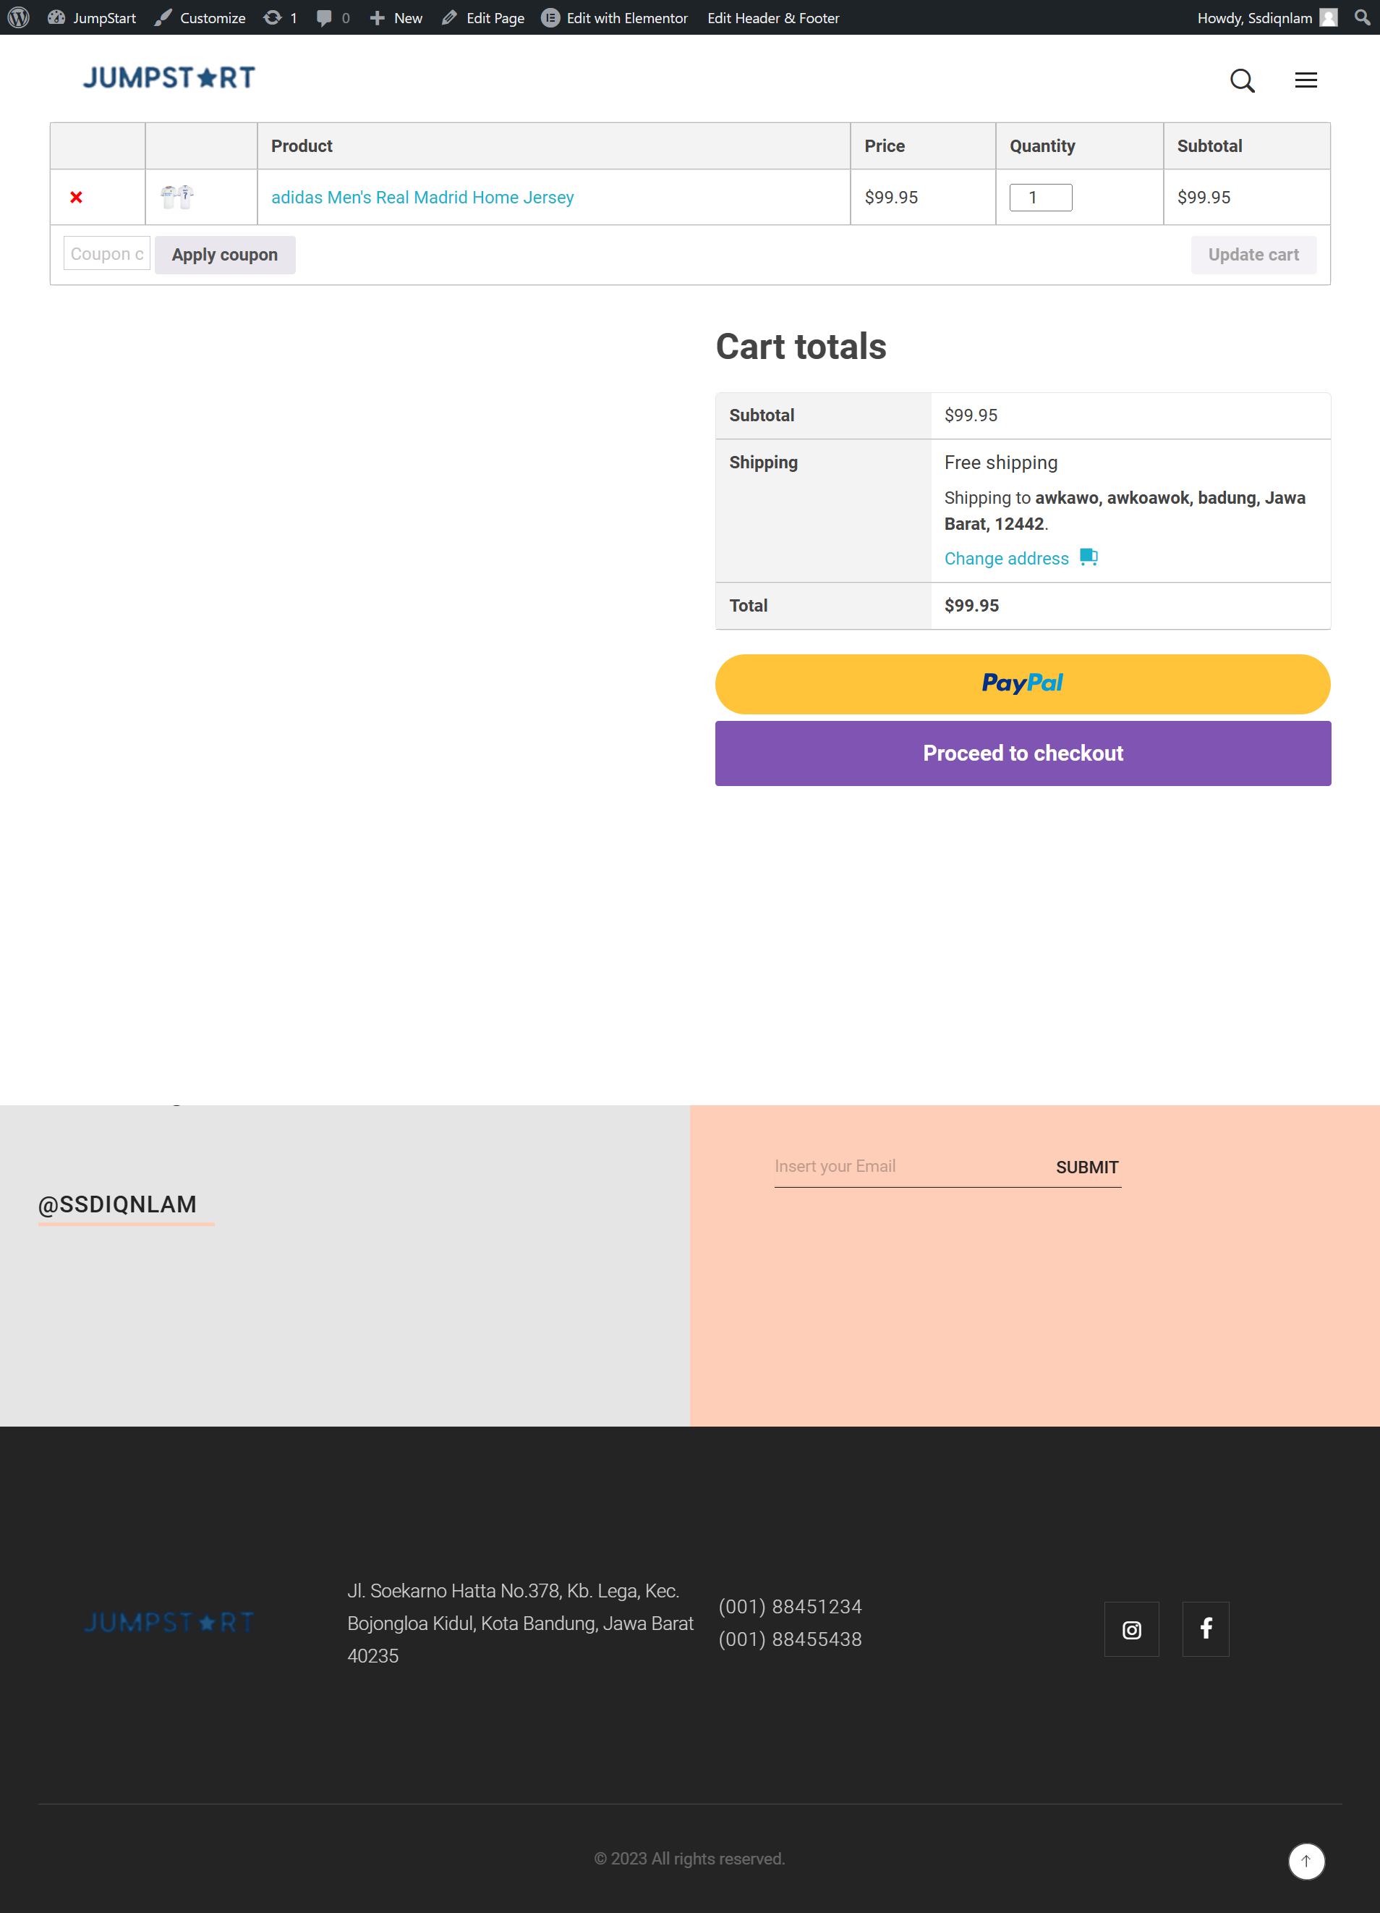

Store

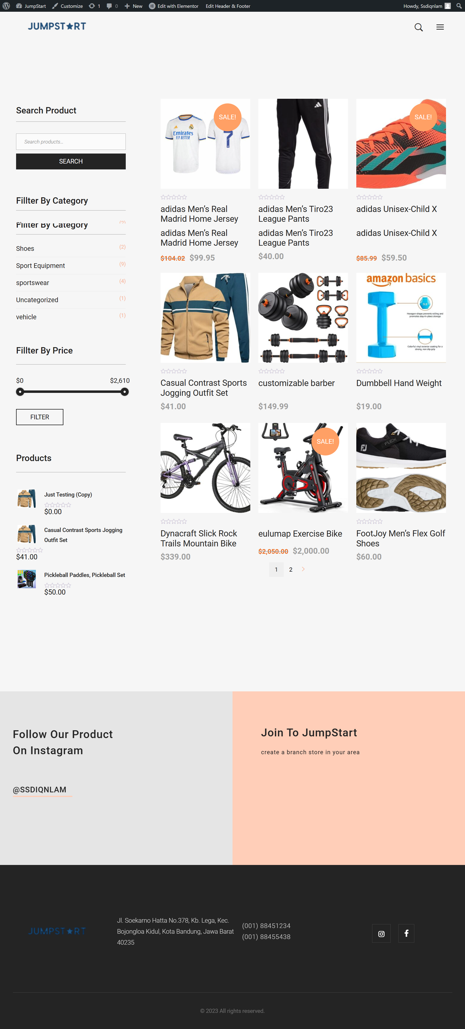

About

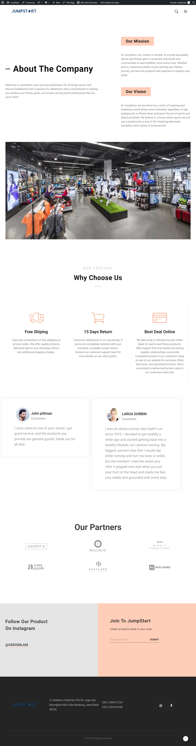

Contact us

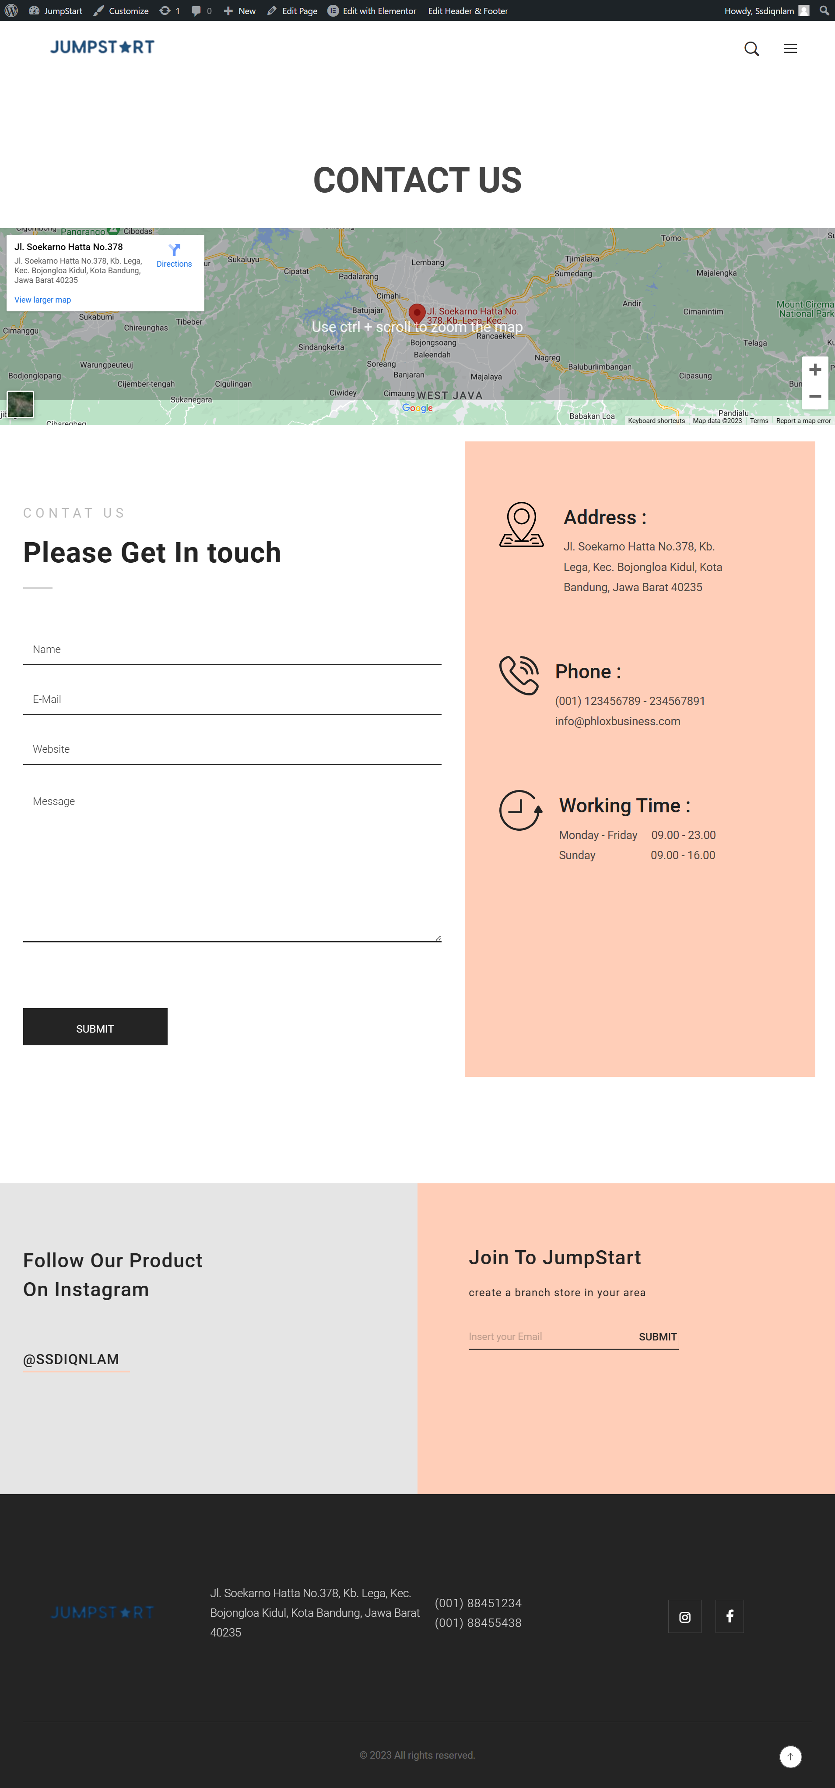

Login

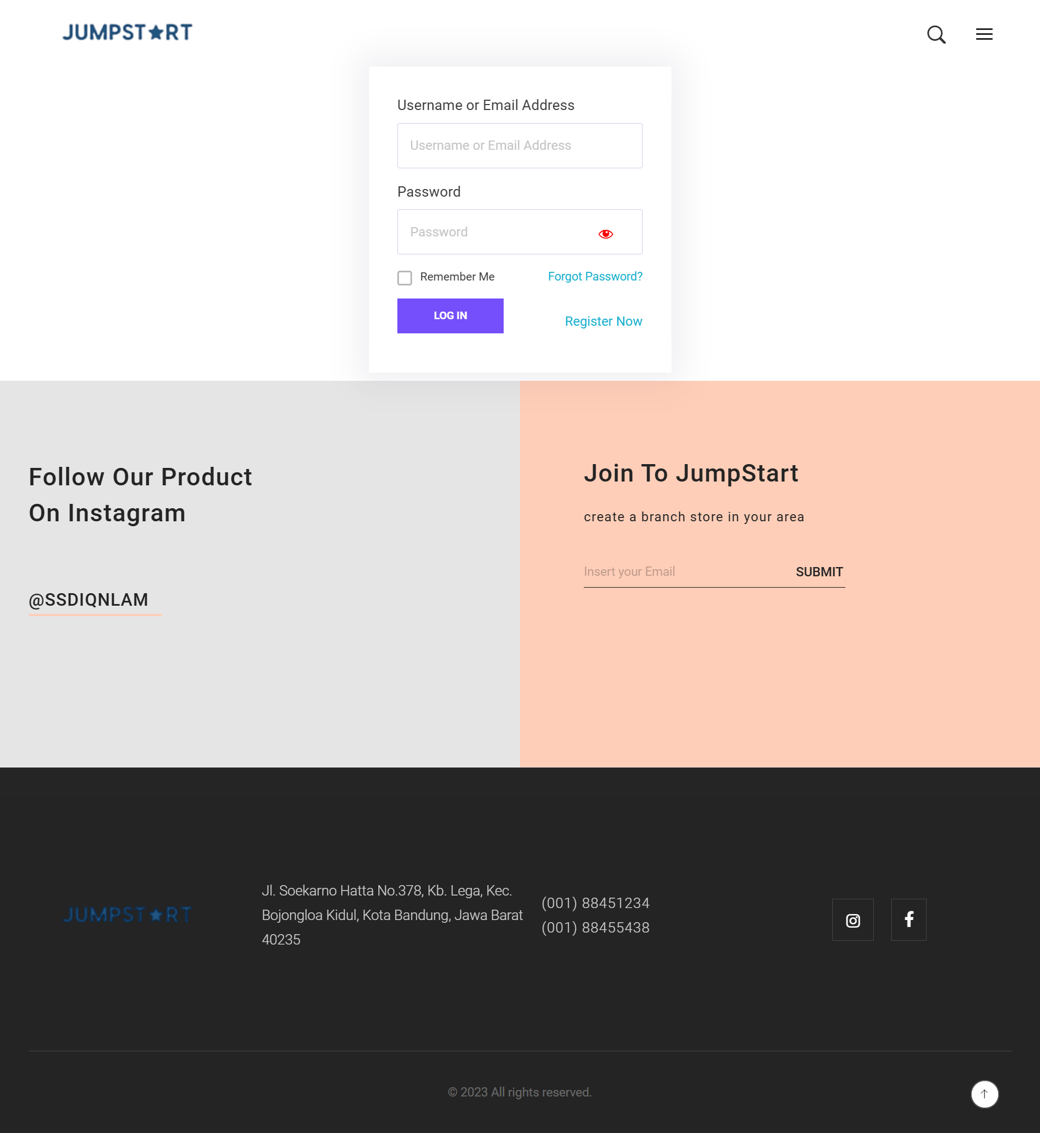

## Reflection on Research Methods

11.1 Effectiveness and challenges of methods applied

(a) Survey:

* + - * Effectiveness: how effective survey techniques have been to achieve CRP objective/goal

very effective because it is possible to find out where the mistakes are and can be corrected immediately.

(b) LR/case study:

* + - * Effectiveness: how effective LR/Case Study techniques had been to achieve CRP objective/goal
      * Challenges:

## Bibliography: in Harvard Referencing system

# References

Creswell, J. W., & David Creswell, J. (n.d.). *Research Design: Qualitative, Quantitative, and Mixed Methods Approaches*.

Deb, D., Dey, R., & Balas, V. E. (2019). Introduction: What is research? In *Intelligent Systems Reference Library* (Vol. 153, pp. 1–7). Springer Science and Business Media Deutschland GmbH. https://doi.org/10.1007/978-981-13-2947-0_1

DeFranco, J. F., & Laplante, P. A. (2017). A content analysis process for qualitative software engineering research. *Innovations in Systems and Software Engineering*, *13*(2–3), 129–141. https://doi.org/10.1007/s11334-017-0287-0

Marczyk, G., DeMatteo, D., & Festinger, D. (2005). *Essentials of Research Design and Methodology* (New Jersey). John Wiley & Sons, Inc.

Moser C.A, & Kalton G. (2016). *Survey Methods in Social Investigation*.

Saunders, M., Lewis, P., Thornhill, A., Lewis, S. •, & Thornhill, •. (n.d.). *Research methods for business students fi fth edition*. www.pearsoned.co.uk

Wohlin, C., & Runeson, P. (2021). Guiding the selection of research methodology in industry–academia collaboration in software engineering. *Information and Software Technology*, *140*. https://doi.org/10.1016/j.infsof.2021.106678